Seed Starting Guide Lines

- Viable seed. A germination test can save time and material, but it doesn’t guarantee that your seeds are fresh. Have they been stored properly? Seeds are still the cheapest gardening investment. Be picky about who gets a spot in the seedling tray!
- Get the best results using a mix made of half coir fiber and half fresh worm castings. It’s that simple! If you don’t have access to either of those, use the very best, still moist, living compost or leaf mold. If you use compost, you should sift it before planting; you want the finest grains, not the sticky clumps.
- The type of container is not important. I like the manufactured seed-starting flats. They are cheap, reusable, and recyclable. They drain well, and everything is contained in a well-fitted tray. If you don’t have these or don’t want them, use any well-drained container that you like.
- Fill the seed cells almost to the top with your starting mix.
- In order to avoid tearing the young roots when you remove the seedlings from the container for transplanting, it is a good idea to tamp down the germinating mix in the cells now.
- After tamping, add chemical-free water to thoroughly moisten the starting mix. If you really want to be nice, use liquid or dry seaweed according to the instructions on the label. Seaweed is a great item to have on the shelf and it keeps indefinitely.
- When the starting mix is moist, you can plant your seeds at the depth specified on the seed packet.
- When the seeds have been planted, spray the top of the cells with water until the mix is well settled.
- After seeding, you can cover the cells with plastic. You can buy fitted plastic covers for seed starting trays, or just use some plastic wrap or a plastic bag.
- Light! You need a strong, reliable light source. You can compromise on many other aspects of gardening, but don’t cheat your green babies on the one thing they need most.
If you have a greenhouse, choose the brightest spot for your new seedlings. If you’ve been setting your seed trays on a windowsill, re-evaluate that choice. Remember: weak light = weak seedlings. If you want husky, healthy seedlings, don’t gamble on the fickle winter sun filtered through a window.
- Setting up a grow light today is easy and inexpensive, and it doesn’t take up much room. If you have some empty space on a bookshelf or an empty shelf in a kitchen cabinet, you can easily install a couple of tiny T-5 light fixtures. There are also several LED offerings on the market. LED grow lights are powerful and super efficient, and they generate very little heat.
Simply attach a light or two to the bottom of one shelf to light the shelf underneath it where your tray will sit. If the shelf is adjustable, you are all set. If not, the tray can be elevated when the seedlings are started, to bring the surface of the soil within two or three inches of the light. That’s right! The light will be very close to the seeds.
If you have room to start seeds on a countertop or a table, there are several tabletop light stands that are designed for the space. The typical design is a simple metal stand that holds the light, suspended by an adjustable string or chain. Tabletop lights are small and easy to use, and they are available in a range of sizes.
The next size up is the shelf model. These resemble a regular set of utility shelves, with a grow light suspended from the bottom of every shelf. These lights offer enough space and power to grow starts for the whole neighborhood! These shelf units aren’t cheap, but they are very useful. In addition to starting seeds they can be used to overwinter plants indoors, and even to grow summer veggies and herbs all winter long.
- one more important factor to consider: time. You need to transition the plants at the right times on their journey to the outdoor garden. Calculate the correct amount of time various plants need to develop to the optimum transplanting size to avoid holding the plants for extended periods. Begin your seeds based on that timetable.
When your seeds germinate, you will see cotyledons. They should be bright green and fleshy, standing on short stems. Now is a good time to remove the plastic covering, if there is any. At this earliest stage you should water the seedlings with a spray bottle, to avoid damaging the delicate young roots. Ideally, you will not need to water, but if the air is dry, the soil may require additional moisture.
Soon the tiny plants will develop their first true leaves. This is a great time for their first feeding.
Wait until the surface of the soil begins to dry out. Use a mild, natural fertilizer mixed at half strength. Fertilize every two weeks until the plants move outside.

Transplant Carefully 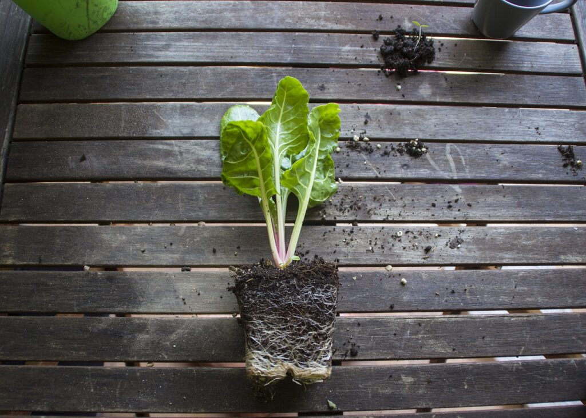
- As the seedlings get larger, adjust the height of the light to keep it at least two inches from the top of the tallest plant, allowing for continued growth. When the root system begins to fill the cell, it is time to move up to a four-inch pot. If you transplant too soon, the seedling can break away from the germination mix, causing the roots to tear. If you wait too long, the roots can become bound and constricted in the cell, restricting optimal growth.
Wait to transplant until the soil is neither too wet nor too dry.
Now is the time when the tamping you did at the beginning is going to pay off. If the transplants are reluctant to pop out of their cells, you can give them a little push from the bottom drain hole using the eraser end of a pencil. If you are pricking out, you should transplant much sooner because a smaller root system is easier to remove intact.
Use potting soil as the growing medium for the four-inch pots, or just add a little perlite to the leftover germination mix. Remember the rule we discussed above: Garden soil belongs in the ground, not in containers.
- After transplanting from the seed cells to the four-inch pots, give the plants a good drench of seaweed. You will still need to raise the lights periodically as the plants get taller. When the plants begin to fill the four-inch pots, you need to decide when they are ready to harden off.
In the case of very cold-sensitive plants like tomatoes, sometimes the weather will not permit you to begin hardening off even though the plant is outgrowing its four-inch pot. You can transplant forward again into a quart-sized pot to buy some more time. It is better to move the plants into a bigger pot than to let the roots become pot bound.
I find that potting forward to larger containers is easier than protecting young outdoor plants from late spring cold snaps.
When you decide it is time to begin hardening off, move the plants outside to a protected area and allow them to begin adapting to the outdoors. Filtered light is good for a day or so, but then don’t hesitate to move them out into the sun. These will be tough little rascals and they will transition to the garden well.
Following these simple steps will get you some of the strongest seedlings you have ever grown, and your spring garden will thrive as a result. After a few rounds of success, you will look at your seed catalogs through new eyes, confident that you can start any seed you want!

